Warwickshire County Council
Transport to schools & other places of education: 22 Mar 21 (v5)
The Government issued guidance about the provision of dedicated home to school transport in the autumn term 2020. This remains in place for the 2020/2021 academic year. The full guidance can be found here
https://www.gov.uk/government/publications/transport-to-school-and-other-places-of-education-autumn-term-2020/transport-to-school-and-other-places-of-education-autumn-term-2020
This guidance document sets out how this is applied in Warwickshire and should be read and adopted by all Council passenger transport operators. Clearly, it is intrinsically relevant to schools and parents/carers.
You should read this guidance with:
- Coronavirus (COVID-19): safer travel guidance for passengers
- Coronavirus (COVID-19): safer transport guidance for operators

For any queries please contact the Council’s Transport Operations team or the Education Transport team, using the contact details shown at the foot of this guidance.
Guidance for dedicated transport to schools and other places of education for academic year 2020 / 2021
Dedicated transport to schools and other places of education often carries the same group of children or young people on a regular basis. They do not mix with the general public on those journeys. This helps limit the number of other people with whom they come into contact.

This guidance aims to help those responsible for the provision of dedicated transport to put in place proportionate safeguards to further minimise the risk of transmission of coronavirus (COVID-19).

It applies to all dedicated transport services which exclusively carry children and young people travelling to their place of education, including mainstream and special schools, colleges and alternative provision settings.

As set out in the guidance for full opening for schools, for special schools, and for places of further education, from the autumn term local authorities will not be required to uniformly apply the social distancing guidelines for public transport on dedicated school or college transport.

Please note Section A – additional guidance issued March 2021
- Safety on School Transport – additional guidance March 2021

We need to ensure that school transport services are as safe as possible, and as such we have expectations on operators and the staff running them -

- Staff should complete Lateral Flow (LFD) tests twice a week on a Sunday or Monday and 3-5 days later. These are quick 30 min tests and can be accessed from the school, local test centres or home test kits.

- Some employers will also have registered to receive them (you have to register before 31st March 2021 using the following link https://www.gov.uk/get-workplace-coronavirus-tests?priority-taxon=774cee22-d896-44c1-a611-e3109cce8eae )
- Home test kits: Find your local collection point here: https://maps.test-and-trace.nhs.uk/
They can also be delivered to your home by Royal Mail, usually within 24hrs. These can be found from this website https://www.gov.uk/order-coronavirus-rapid-lateral-flow-tests
- Book a test a an LFT test centre:
Book a rapid testing slot in North Warwickshire (Water Orton Methodist Hall)
Book a rapid testing slot in Bedworth (Saunders Club)
Book a rapid testing slot in Nuneaton (United Reform Church)
Book a rapid testing slot in Rugby (Indian Club)
Book a rapid testing slot in Leamington (Pound Lane)
Book a rapid testing slot in Stratford (Courtyard Theatre)

- If staff are unwell with a cough, high temperature loss or change in sense of smell they should not attend work and they and their household should isolate, book a PCR test and only stop isolating when a PCR test is negative. PCR tests usually take 24-48hrs for a result.

- Staff should not attend work if they are a close contact of a positive case; have a positive case in their household; someone in their household has a cough, temperature or loss or change in sense of smell. In such cases this will be until the completion of 10 days isolation following a positive PCR test or until that household member has tested negative by PCR following the symptoms.

- While COVID-19 usually presents with a new or worsening cough, high temperature and loss or change in taste or smell it can present as cold symptoms such as; sore throat, severe fatigue/ feeling unwell for no clear reason, poorly tummy, severe headache and muscle aches.
If staff are unwell with these lesser symptoms, please consider the impact on transporting children who are clinically vulnerable, as WCC and Public Health would rather they not work when ill and PCR test (24-48hr test results) whilst recovering to ensure that it is not COVID-19. At a minimum they must LFD test (results in 30 mins) if they have the lesser symptoms.
Their household does not need to isolate if they undertake a PCR test. These can be booked online or with 119 by stating they do not have top three symptoms online but “Public Health has requested I book a test”. They are permitted to have a test without symptoms, the household legally do not need to isolate.

- Staff should remain 2 metres from any child or carer being transported where this is possible.

- As it is likely that they must be within 2 metres on transport face coverings are expected to be worn correctly and on transport to special schools PPE may be requested and must be worn correctly. These must be over the mouth and nose at all times. It is best practice to not remove these between groups of passengers unless they become wet or dirty. It is best to keep touching and handling to a minimum.

- Staff should sanitise their hands before work, after work, and anytime the vehicle has been cleaned down in between different school runs or groups of passengers. Also, when transporting wheelchairs or aiding/touching children, and before and after any contact with clients or their equipment.

- Staff should not mix with other drivers or passenger assistants at drop off or pickups. This includes close contact discussions and unless required for the role and approved by managers at the company or school staff they should not enter the vehicle of another school transport service. It is best to avoid all interaction with others on school or college sites – even in the open air to reduce risks considerably.

- Minimise contact with individuals who are unwell

- Children or young people must not board home to school transport if they, or a member of their household, has symptoms of coronavirus (COVID-19). which include a new, continuous cough, high temperature, or loss of taste or smell, or if they live in a household with someone showing any of these symptoms – they should self-isolate and stay at home.
- Drivers and passenger assistants must not work if they have symptoms, or if someone in their household does. If they develop symptoms whilst at work they must go home and get a test.
- Anyone with symptoms must follow Stay at home: guidance for households with possible or confirmed coronavirus (COVID-19) infection.
- The Government’s specific Covid-19 advice for staff in the transport sector should be followed and is at this link: https://www.gov.uk/government/publications/coronavirus-covid-19-safer-transport-guidance-for-operators

- Cleaning and hygiene measures

- Clean hands thoroughly more often than usual
- Coronavirus (COVID-19) is an easy virus to kill when it is on skin. This can be done with soap and running water or hand sanitiser.
- Children, young people, drivers and passenger assistants must clean their hands before boarding transport and again on disembarking.
- Drivers and passenger assistants should use alcohol hand rub or sanitiser at intervals throughout the journey, and should always do so after performing tasks such as helping a child into the vehicle or handling a child’s belongings.
- Catch it, bin it, kill it.
The ‘catch it, bin it, kill it’ approach is very important. Schools will be reinforcing this message with children, Children will be encouraged to carry tissues on home to school transport. These will need to be disposed of in a covered bin. Where it is not possible to have a bin on board, schools should have a suitable disposal process on arrival
- Vehicle cleaning
- All touch points on school transport vehicles must be cleaned to protect against Coronavirus/Covid-19 prior to and after every new journey – this includes door handles, keys, handrails, armrests, seat backs, seatbelts, driver controls, etc. Enhanced cleaning should take place at the end of each day. Coronavirus (COVID-19) is easy to kill on surfaces. Normal cleaning products will do this - specialist cleaning products are not needed. For more information on keeping public and private areas and modes of transport clean, read Coronavirus (COVID-19): safer transport guidance for operators
- Operators are required to keep a “Cleaning log sheet” for each vehicle using the template supplied with this guidance. This must be completed to show when cleaning has been completed, and whether it was a contact point or enhanced clean. This must be available to present to WCC officers, or staff from schools on request.
- On-board cleaning fluids/cloths/disposable gloves and a suitable secure on-board bin or bag for disposal of any cleaning items, tissues or PPE, for in-journey use, should be provided and emptied after each run, or at the minimum at the end of every day.

- The journey

- We expect pupils to be socially distanced whilst queuing, boarding and alighting vehicles where possible. This is a parental responsibility.
Operators should work with schools and follow their guidance regarding appropriate queuing or other arrangements needed for picking up and dropping off children and young people, to ensure they are able maintain distancing when waiting for, boarding and alighting from transport.

- Operators should work with schools, places of education to draw up seating arrangements so that children and young people understand where they need to sit on home to school transport - ensuring the same children always sit together will help to minimise the number of contacts each child has.
  - Children should sit in the same seat and row every day. In the event of a positive case this will help with Track and Trace.
  - Where possible pupils should sit in groups that reflect the bubbles or year groups that are adopted within school. Pupils are therefore asked to sit with peers from their own school and their own school year group.
  - NB – it is not the driver’s role to ensure children are in the correct seats – if there are problems these should be reported to the school.
- Avoid the use of face to face seating wherever possible.
- Ensure good ventilation of fresh air wherever possible by keeping windows or roof lights open.
- Only entitled pupils may travel on the school bus/taxi

- Face coverings

- In accordance with advice from PHE, children and young people aged 11 and over attending mainstream schools should wear a face covering when travelling on dedicated transport. This does not apply to people who are exempt from wearing a face covering on public transport.
The government has adopted this position in light of all children returning to education full-time and the fact that ‘1 metre plus’ social distancing measures will not uniformly apply on dedicated school or college transport.

- A face covering is a covering of any type which covers your nose and mouth. Reusable or single-use face coverings are available for parents and carers to buy. A scarf, bandana, religious garment or hand-made cloth covering may also be used but these must securely fit round the side of the face.
Face coverings:
- may be particularly useful where measures such as distancing and sitting in bubbles or year groups are not possible
- may help children to feel more confident about using home to school transport, and parents to feel more confident about their child using home to school transport
- should not be worn by those who may not be able to handle them as directed (for example, young children, or those with SEND) as it may inadvertently increase the risk of transmission
- are not a substitute for other protective measures such as good hand hygiene
Children under 11 may wear a face covering if they are able to handle it as directed.

- Children with SEND and face coverings
- Special schools tend to be smaller, meaning all the children in a school might be in the same bubble, and transport typically uses smaller vehicles. Both these things will help to minimise the number of contacts children with SEND have on school transport.
- Some children and young people with SEND will not be able to use a face covering properly and should not be expected to do so as this may increase the risk of transmission. Some children may be distressed by wearing a face covering, or by others wearing them. Others may become distressed if they and other people do not wear them.
- Some children and young people may need to be able to lip read, or see people’s faces, to communicate. There are companies now making lip-reading friendly face coverings.
- Some children with SEND display behaviours such as spitting uncontrollably. In circumstances such as these, maintaining distance on transport is particularly desirable.
- We recognise that transporting children and young people with SEND may require close contact. Where this is the case, other measures in the system of controls should be put in place to reduce risk. If this is provided by staff independent of the school and they are within 2m of the child a surgical face mask (not fluid repellent) should be worn to protect the pupil.
Additionally, staff may want to wash or sanitise their hands more frequently.

- Personal Protective Equipment

PPE is not normally needed on home to school transport
- By PPE, we mean equipment such as fluid-resistant surgical face masks, disposable gloves, disposable plastic aprons and eye protection such as a face visor or goggles.
- Drivers and passenger assistants will not normally require PPE on home to school transport, even if they are not able to maintain a distance from the children and young people on the transport. This is because, as set out above, children and young people with symptoms of coronavirus (COVID-19) must not board home to school transport. Where the care a child or young person ordinarily receives on home to school transport requires the use of PPE, that should continue as usual.
- For SEND pupils where transporting them requires close contact, as outlined in section D3 above, a surgical face mask should be worn by drivers and passenger assistants.
- For more information, read:
How should I care for children who regularly spit or require physical contact?

Guidance on the specific steps that should be taken to care for children with complex medical needs, such as tracheostomies (this includes aerosol generating procedures)

- Warwickshire County Council Policy – Face-coverings
- It is Warwickshire County Council policy that cloth face coverings be worn by drivers and passenger assistants (examples of which are outlined above). Rigorous handwashing is necessary before and after putting on the coverings and after taking off (plus washing them every day). Staff may choose to wear more than this including other PPE – this is accepted but is not a requirement.
- As outlined above in sections D3 and D4 the wearing of a surgical face mask will apply for transporting SEND pupils where close contact is required.

- Workforce
- Implementing the measures in this guidance will reduce the risk to all staff.
- Drivers and passenger assistants should maintain a distance from their passengers wherever possible. We acknowledge that the nature of school transport, and the needs of the children and young people receiving it, mean this will not always be possible. Drivers may be able to leave the vehicle to maintain distance while children and young people are getting on and off.
- Where primary school pupils have difficulty fitting seat belts themselves, the driver should offer verbal guidance and support from a safe distance – seat belts should be pre-adjusted for pupil use
- Drivers should not be expected to police arrangements such as seating plans, queues, the wearing of face coverings or use of hand sanitiser - their role is to focus on driving the vehicle safely
- Behaviour
We do not expect drivers to police pupil behaviour. Their role is to focus on driving the vehicle safely. If issues occur these should be reported to us. Where pupils/passengers do not behave in accordance with transport guidance and/or generate an unacceptable safety risk to staff, they will be refused transport by WCC without notice
- At the end of their shift, drivers and Passenger Assistants (PAs) should minimise possible contamination before entering their own home – key things to do include washing with soap and water, and isolating clothes and personal effects in a box prior to cleaning
- For SEND transport services –
- If staff need to fasten a passenger’s seat belt/harness, this should be done with minimal physical contact and avoiding face to face contact where possible. As noted in Section D3 of this guidance, if this is provided by staff independent of the school and they are withing 2 metres of the child, a surgical face mask (not fluid repellent) should be worn to protect the pupil.
- If staff have to manoeuvre wheelchairs, they should clean the wheelchair handles and brake levers prior to pushing the wheelchair. Likewise, if installing car seats or booster seats, clean the hard surface areas (e.g. outer shell, buckles) before installing in the vehicle and clean them after use. Staff should wear disposable gloves when cleaning, and a bag provided to dispose of them after use.
- Any unnecessary moving and handling or close sustained contact with the pupil/passenger will be avoided

- Prevention, identification of and measures to address a positive case of COVID-19
Following seating plans for every bus whereby seats are allocated by the school or transport provider, grouped by year, followed by children, policed by schools and parents to ensure children sit in those seats, we can best identify which children have sat together.
Without this a whole bus will need to self isolate if there is a positive case.

When travelling in consistent groups such as on transport to schools:
- Pupils and clients on dedicated services do not mix with the general public on those journeys and tend to be consistent.
- The advice for passengers on public transport is to adopt a social distance of 2 metres from people outside their household or support bubble, or a ‘one metre plus’ approach where this is not possible.

Guidance for safe travel and to control a situation should there be cases of COVID-19:
- Children over 11yrs should wear face-coverings to travel.
- Each child must sit in the same seat every day.
- School groups should sit together.
- Year groups should sit together
- Bus companies need to label seats with numbers to enable adjoining seats to be easily identified and reported.
- It is not the driver’s role to ensure children sit in the right seats.
- Parents and the school need to know which seat their child sits in
- There needs to be a central list in place of children traveling to school on which bus (with seat numbers, names and phone numbers). The central list needs to be held by an accessible point of contact in the school for out of hours use.
- When a child is found to be positive, it is important the parent inform the school, report that they travel on the bus and in which seat.
- The central list will be used so that close contacts can be identified and informed. This will ensure they do not attempt to attend school or board the bus.
- Should there be a positive case of COVID-19 on bus, only children who sit within 2 metres of the case need to self-isolate.
- Should a positive case be linked to a bus; parents need to be prepared to collect their child. They may be notified of this during a school day and will need to collect their child to allow for self-isolation

Figures 1,2 and 3 that follow show how this will be put into practice.

Figure 1 and 2: How a positive case on a bus does and doesn’t affect school.

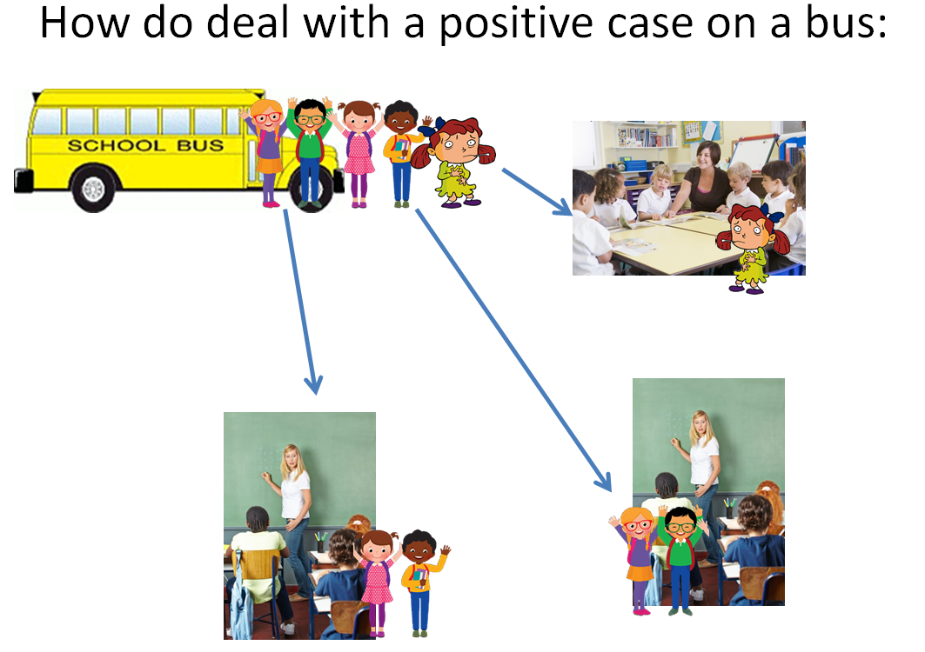
Children on a bus to school, 1 child is unwell and tests positive for COVID-19. They travel with 4 children from 2 different classes in school or even different schools. As you can see, only 1 school class needs to isolate due to being in direct contact with the person who is COVID-19 positive. The 4 bus contacts need to isolate but not their classes.
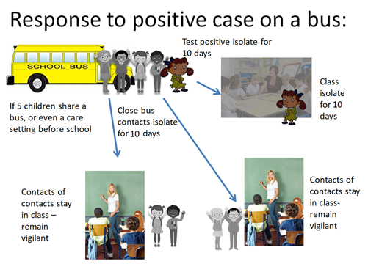

Figure 3: How children are identified to self-isolate following a positive case on a bus

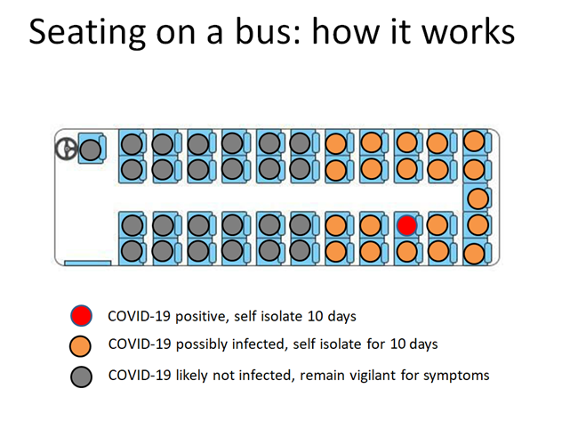

- Contacts
Warwickshire County Council, Shire Hall, Warwick, CV34 4RL
Phone: 01926 412929
Email: to@warwickshire.gov.uk (mainstream, SEND and adults. Using buses, coaches, taxis and private hire vehicles - Transport Operations)
Email: educationtransport@warwickshire.gov.uk (policy queries - Education Transport)
Web: www.warwickshire.gov.uk

v.5. 22nd March 2021
Att: Vehicle Cleaning Schedule template.

