Dear Parents and Carers,

Our schools and early years settings are continuing to work hard to maintain provision for your children by reducing bubbles sizes, documenting seating plans, asking for close contact details, supporting families with IT where possible and provision of food parcels to eligible pupils during self-isolation.

We know that you may be getting tired of all the information about Coronavirus and could be feeling exhausted and frustrated. Support is available if you need it from schools, settings, or the council at www.warwickshire.gov.uk/coronavirus. We have come so far together and if we continue to support each other to follow guidance and stay safe we will have a better chance of controlling the virus and keeping well.

There are four weeks until the end of term and what we all do now, in Warwickshire, will have a massive impact on transmission leading up to the festive period - which we all want to be as close to normal as possible.

Wards which have the highest numbers of cases in this area are Benn, Coton and Boughton and Eastlands¹. We wish to focus efforts even more in these particular wards to stop this increase in cases. In all five of Warwickshire’s districts and boroughs the highest transmission is caused by meeting with others in home settings.

What our families do, in our communities, has a massive impact on schools and early years settings. For example, we have had situations where some children have experienced multiple episodes of self-isolations due to positive cases at settings. However, there are still some simple things you can do help your child remain in childcare or education and prevent transmission of Coronavirus.

- Follow lockdown rules now and after lockdown by limiting social interactions and socially distancing when you do. Spread into settings is due to social interactions outside. Doing as much as you’re able to will prevent your families from being exposed to Coronavirus and minimises exposure risk for the setting.
- Maintaining social distancing from others is the best way to prevent spread whether you’re indoors or outdoors or wearing a face covering. Remember to keep 2 metres away from others.
- If you, or anyone in your household, is unwell with a new or worsening cough, a high temperature, loss or change in taste or smell, then please self-isolate and get a Coronavirus test. Do not send your child into school and do wait for the test result. Your child can return to school if your result is negative.

There are three main symptoms of Coronavirus - a cough, loss or change in sense of smell or taste or a high temperature. When anyone displays these symptoms it is most likely a Coronavirus infection, we therefore ask you to isolate with your household, book a test, and if positive self-isolate for 10 days if you were the one who tested positive, and 10 days if you are a household contact.

We are all working tirelessly to maintain education provision in this crisis, we ask for your support in ensuring that schools and early years settings continue to remain open.

Yours sincerely
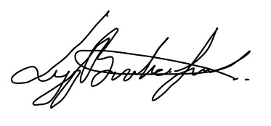

Liann Brookes-Smith Mannie Ketley
Associate Director Public Health Chief Executive
Warwickshire County Council Rugby Borough Council

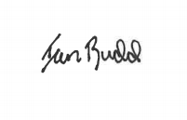
Ian Budd
Assistant Director of Education Services
Warwickshire County Council

¹ Data at 18th November based on positive cases with a specimen date between 23rd October to 12th November

